**Course Specialist Test 2 Year 12**

Student name: ________________ Teacher name: ________________

**Task type: Response/Investigation**

**Reading time for this test : 5 mins**

**Working time allowed for this task: 40 mins**

**Number of questions: 7**

**Materials required:** Upto 3 classpads/calculators

Standard items: Pens (blue/black preferred), pencils (including coloured), sharpener, correction fluid/tape, eraser, ruler, highlighters

Special items: Drawing instruments, templates, notes on one unfolded sheet of   
A4 paper SINGLE SIDED, and up to three calculators approved for use in the WACE examinations

**Marks available: 40 marks**

**Task weighting: 13%**

**Formula sheet provided: no but formulae stated on page 2**

**Note: All part questions worth more than 2 marks require working to obtain full marks.**

**Useful formulae**

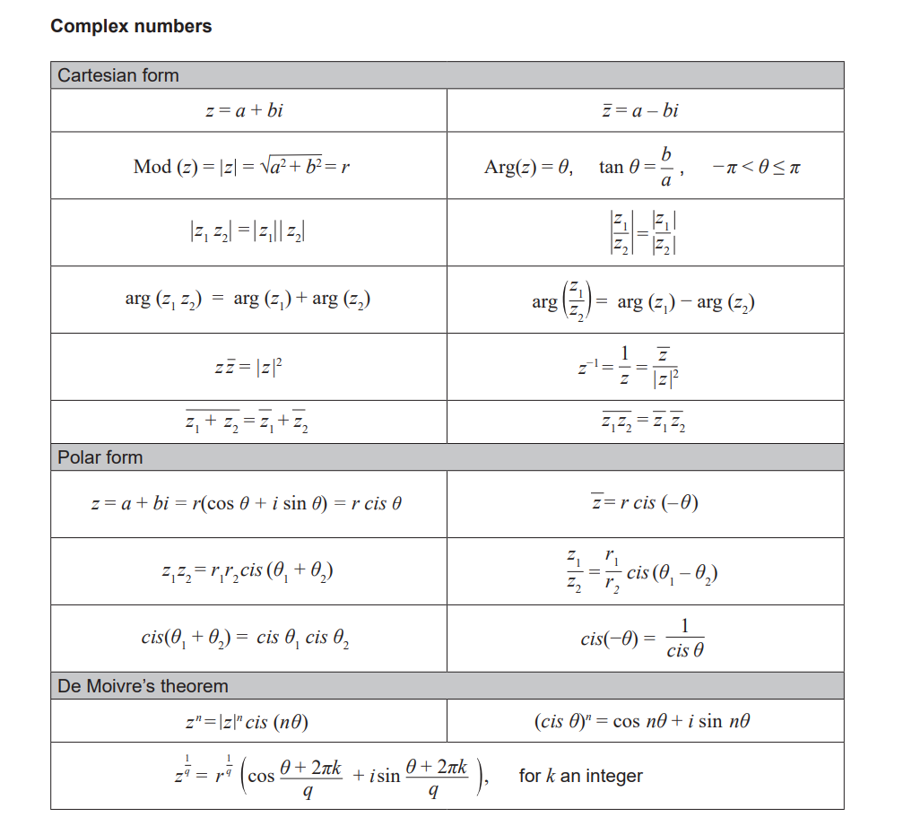

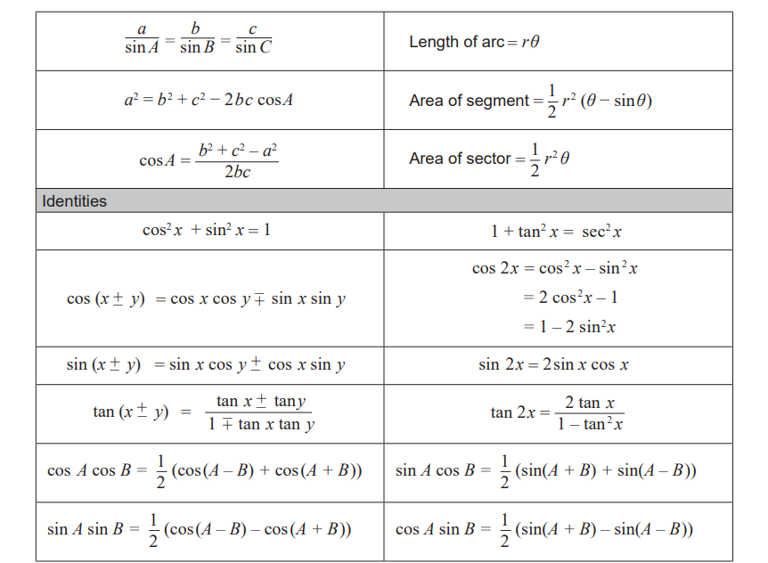 Q1 (3 marks)

Consider the inequality  which is only true for  where  are constants.

Determine the values of .

Q2 (4 marks)

Consider two ships  moving with constant velocities and the following noted position vectors.



Determine if the ships will collide and if they do, determine the time and position of this collision.

Q3 (2, 3 & 3 = 8 marks)

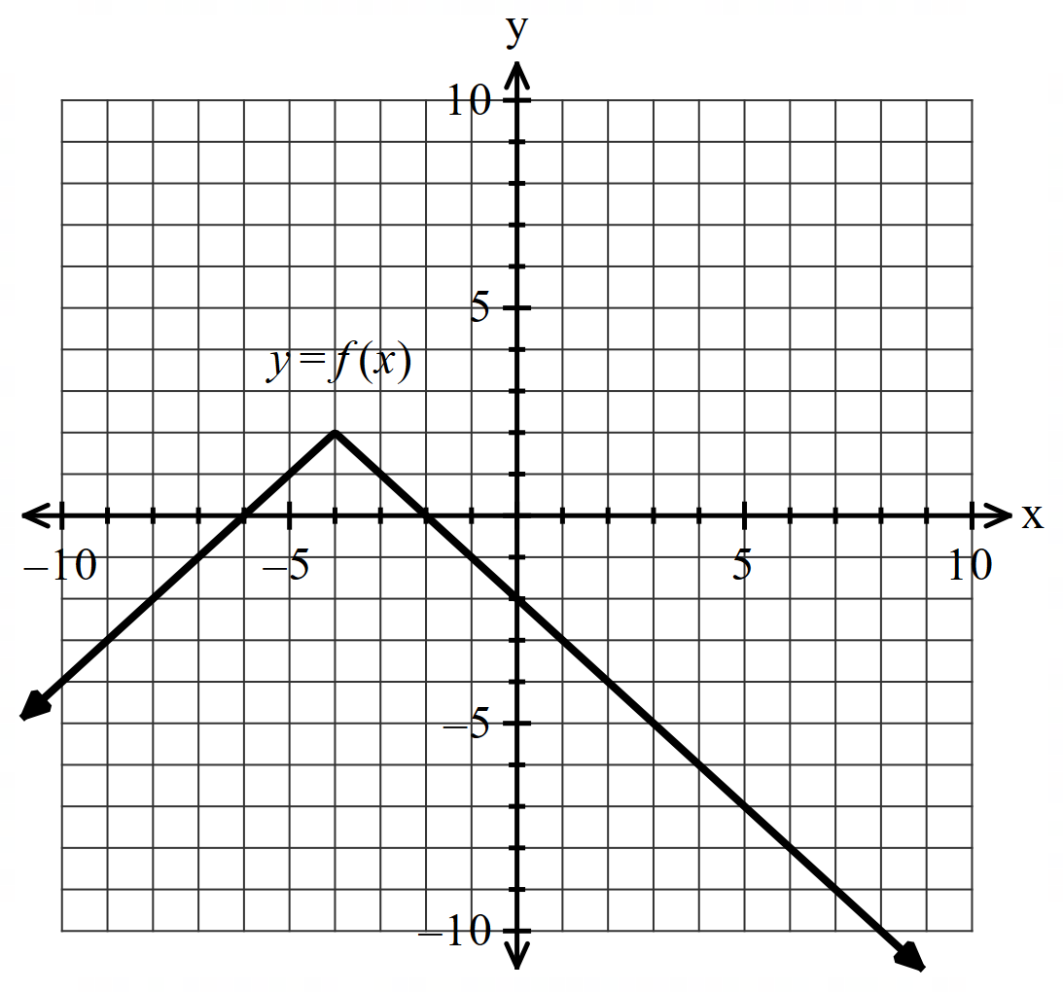Consider the function  below.

Sketch on the given axes the following:

1. Sketch  on the axes below.

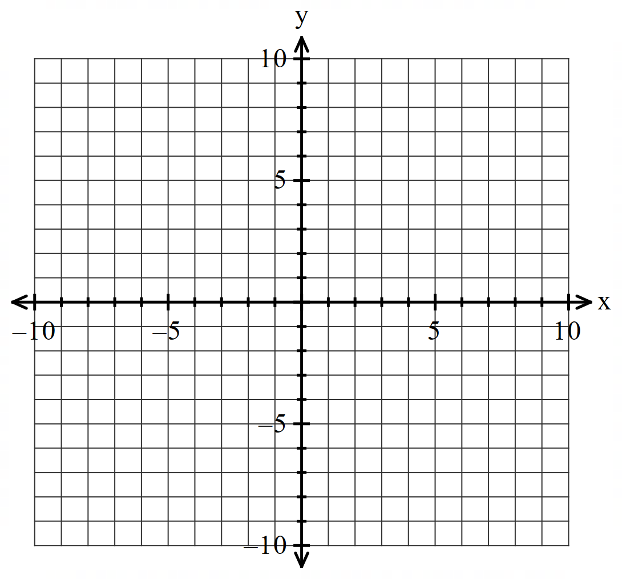

1. Sketch  on the axes below.

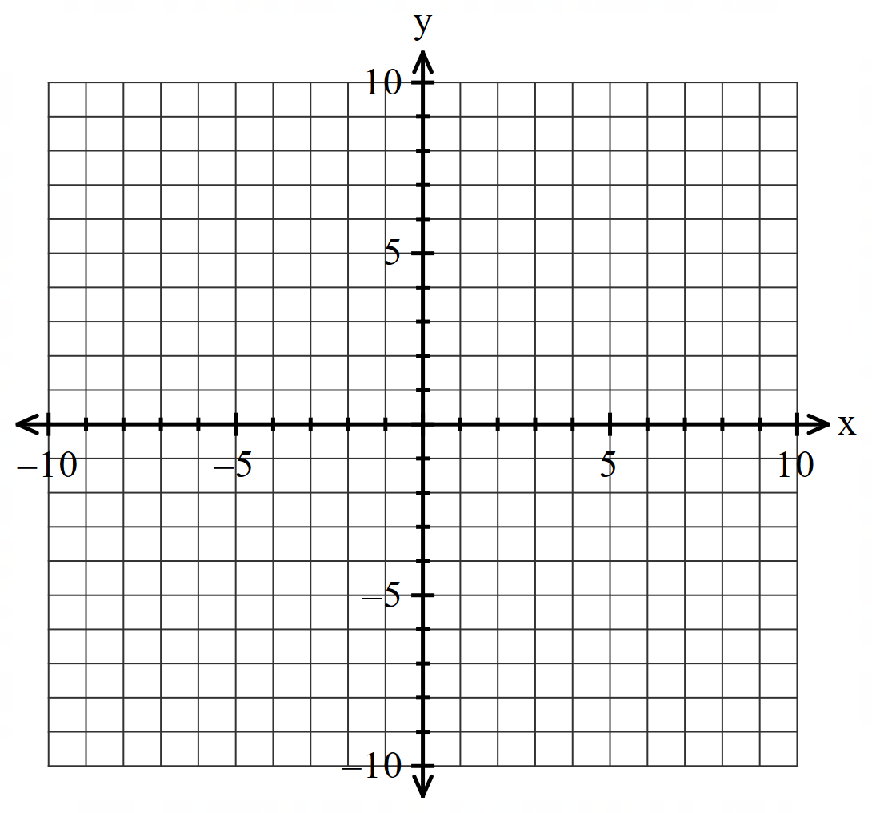

1. Sketch  on the axes below.

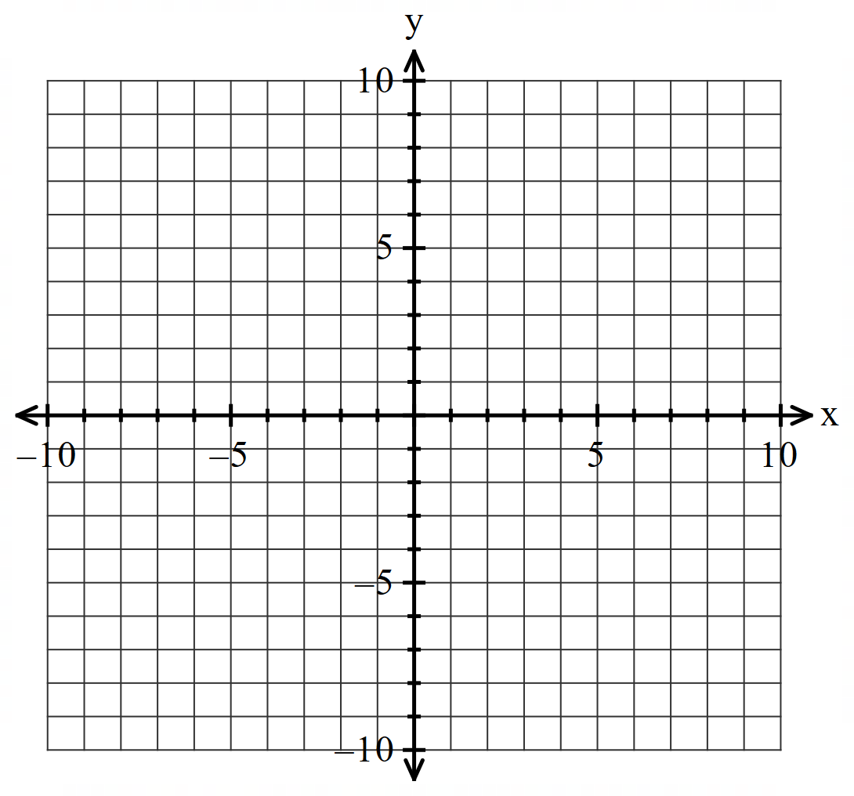

Q4 (2, 3, 1 & 3 =9 marks)

Consider  for  which is plotted below.

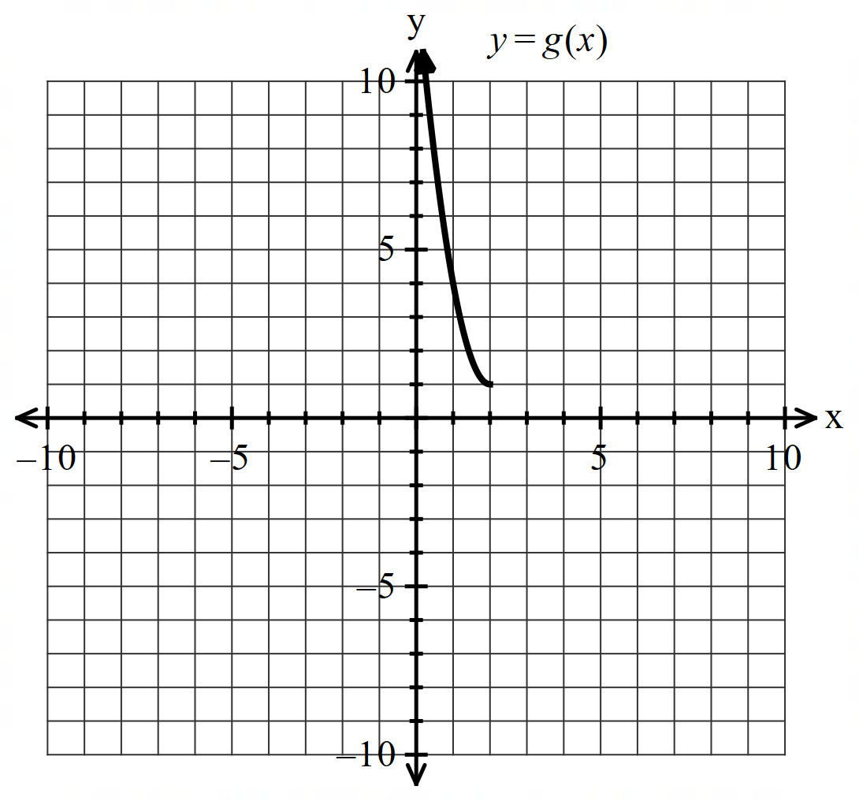

1. Sketch  on the axes above.
2. Determine the rule for showing full working and the domain.

Q4 cont-

1. Determine .
2. Determine all value(s) of  such that . Show reasoning for full marks.

Q5 (5 marks)

Consider two moving objects  which at time  seconds have the following positions and constant velocities.



Determine the minimum distance between them **using vectors** and the time that this occurs.

Q6 (5 marks)

Consider the line  and the circle  where  is a constant.

Determine all possible values of such that:

1. The line will be a tangent to the circle.
2. The line crosses the circle at two points.
3. The line will never meet the circle.

Q7 (2 & 4 = 6 marks)

Consider complex numbers . It is known that:

 where 

 such that  where 

1. Represent this information on the Argand Diagram below.

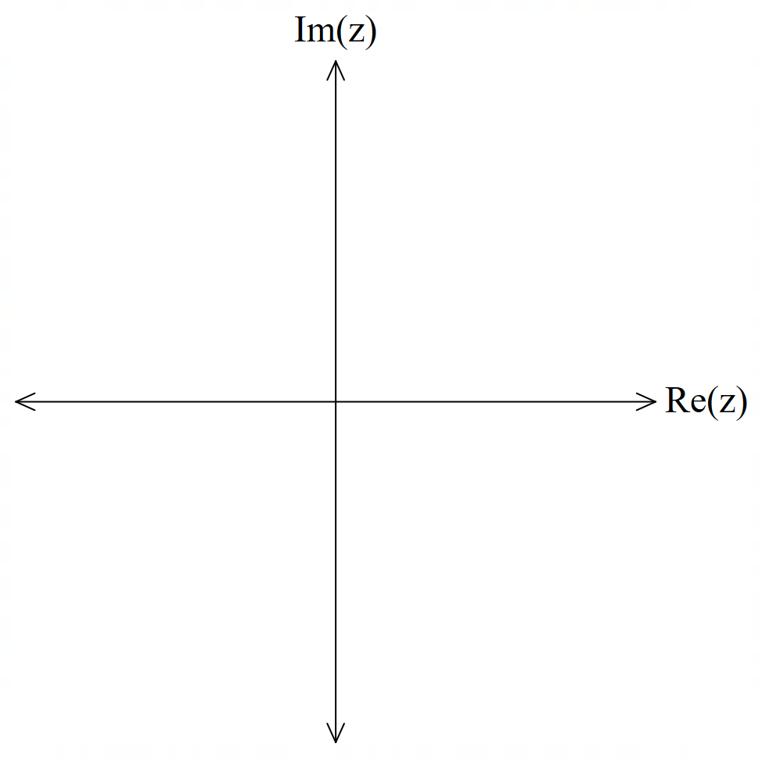

1. Determine a **simplified** expression for  in terms of . Justify your answer.

Working out space

Working out space